TRAFFIC DEMAND PREDECTION USING MACHINE LEARNING



Problem statement:
Accurately predict traffic demand(vehicle count)for future time intervals at different road segments considering weather,events,time and road infrastructure
Contents:
- Abstract
- Introduction & Objectives
- Dataset & Features
- Methodology
- Machine Learning Models
- Results
- Web Application
- Conclusion & Future Scope

Abstract
Traffic congestion has become a major challenge in urban areas due to the increasing number of vehicles. Predicting traffic demand in advance helps improve traffic management and reduces congestion.
This project develops a Traffic Demand Prediction System using Machine Learning. A synthetic dataset was generated using Python with features such as road type, number of lanes, weather conditions, temperature, humidity, speed limit, nearby intersections, and event type. Data preprocessing and feature selection were performed before training the machine learning models.
Two regression algorithms, LightGBM and XGBoost, were trained and evaluated using R² Score, MAE, and RMSE. The best-performing model was saved and integrated into a Flask web application where users can enter traffic-related details and receive predicted traffic demand.
Introduction
Traffic congestion affects travel time, fuel consumption, and air pollution. Machine Learning helps analyze historical traffic patterns and predict future traffic demand. This project provides a simple web-based application that predicts traffic demand using road, weather, and time-related information.
Objectives
- Generate a synthetic traffic dataset.
- Preprocess and clean the dataset.
- Select important features.
- Train LightGBM and XGBoost models.
- Compare model performance.
- Develop a Flask web application.
- Predict traffic demand based on user inputs.

Dataset & Features
Dataset Description
A synthetic traffic dataset was generated using Python.
The dataset contains:
- Road Type
- Number of Lanes
- Speed Limit
- Day of Week
- Hour
- Weather Condition
- Temperature
- Humidity
- Rainfall
- Wind Speed
- Visibility
- Nearby Intersections
- Event Type
- Peak Hour
- Traffic Demand (Target Variable)

Methodology
Dataset Generation
↓
Data Preprocessing
↓
Feature Selection
↓
Train-Test Split
↓
LightGBM Model
↓
XGBoost Model
↓
Model Comparison
↓
Best Model Selection
↓
Flask Web Application
↓
Traffic Prediction

Machine Learning Models
LightGBM
Models Used
LightGBM is a gradient boosting algorithm designed for fast and accurate predictions. It efficiently handles large datasets and improves prediction performance.
XGBoost
XGBoost is an optimized gradient boosting algorithm widely used for regression and classification tasks. It provides high prediction accuracy and handles complex relationships between features.
Evaluation Metrics
- R² Score
- Mean Absolute Error (MAE)
- Root Mean Square Error (RMSE)

Output:
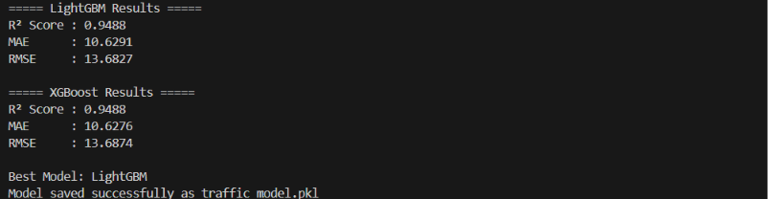

Results:
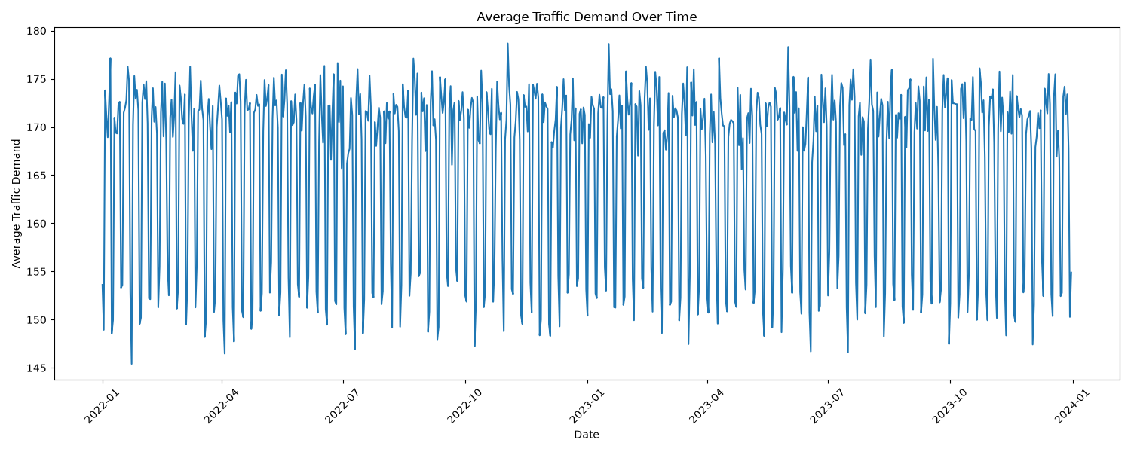
Fig1:Traffic Demand Over Time
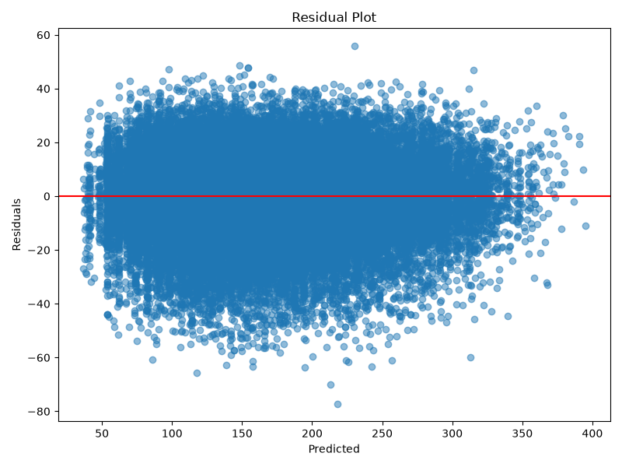
Fig2:Residual Plot
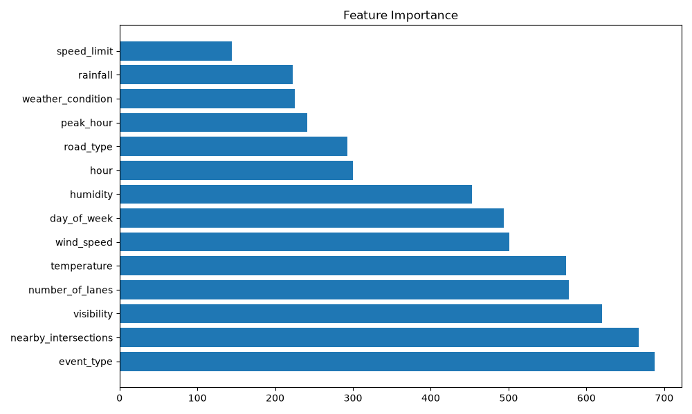
Fig3:Feature Importance
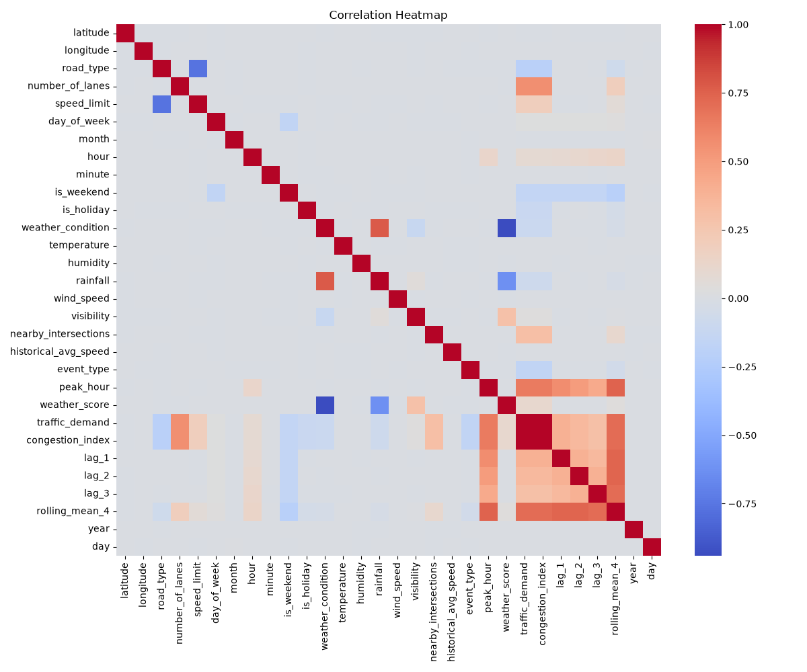Fig4:Heatmap
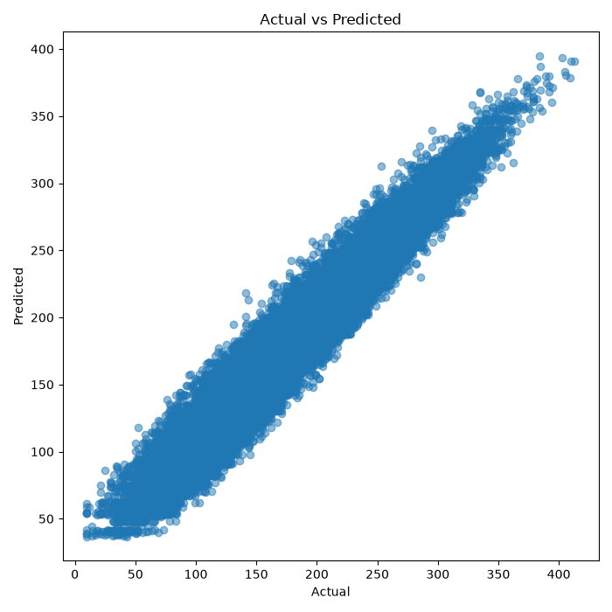
Fig5:Actual vs Predicted

Web Application:
